Ballad of The Telephone Pioneers
by Joe Cyr
( dedicated to Margie Wilson, 1912-1999 - a Telephone Pioneer )

‘Phone Pioneers of America - the “TPA”
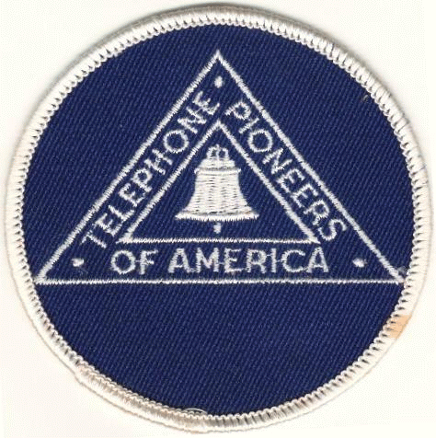
We toast these workers of a former day.
On insulators phone wires buzzed and murmured
While Pioneers communications nurtured.

When phone wires hummed on crowded poles
That followed along tracks of railroads.
Linemen paced miles of strung-out lines
Where insulators gleam’d like tiny shrines.

Operators with blonde hair or auburn curls -
Across the land, these vital girls
Would greet you warmly with “Number Please”
And connected you with practiced ease.

Turned we to these heroines of communication
Oft’ for time of day and number information.
Switchboards were run by these ‘Pioneers’
Through most of twentieth century’s years.

Now, these gentle souls no more stand by
To connect your party with repeated try;
Replaced at last throughout the nation
By cell phones and other automation.

REFRAIN
Our Margie was one of these Pioneers
With Southwestern Bell for many years.
She glowed young glory and spirit then,
In simpler times ne’er to be seen again.

( Optional stanza; the “beepball” was designed for sightless kids. The Telephone Pioneers also devised “beep” bases, the “Playground Map”, and sponsor other community projects )

Retired now, but they still serve us all;
Pioneers have invented the “ beepball,”
And help communities in many ways
So continue to earn their honor’d praise.

